ANNEX 1:

Session 1B – Step 1: Pictures to compare between Well-nourished and Undernourished

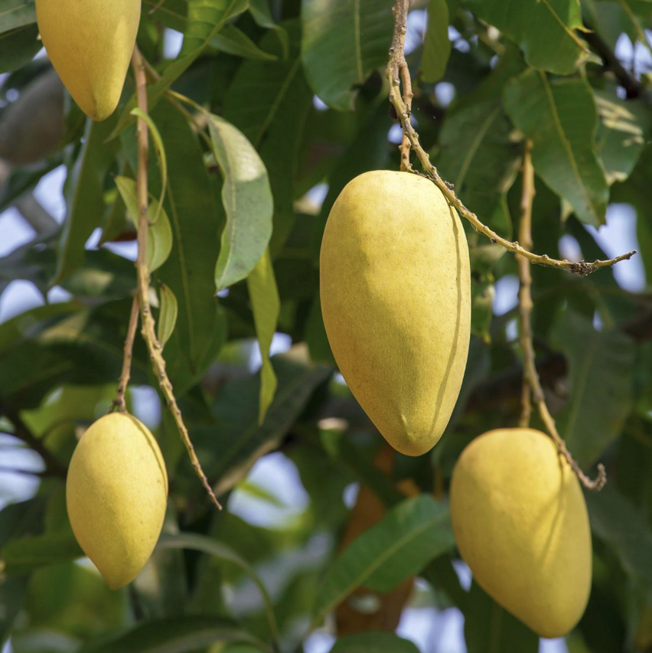
1

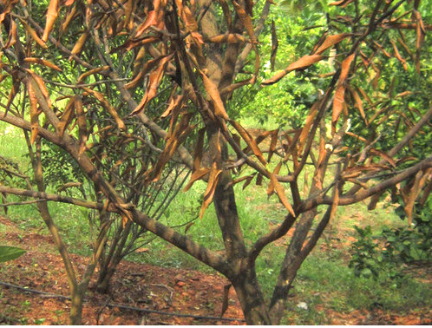
2

